Department of CSE SOLAR TRACKING SYSTEM

CHAPTER-1

INTRODUCTION

1.1 Introduction
Solar energy is clean and available in abundance. When it comes to the development of any nation, energy is the main driving factor. Solar technologies use the sun for provision of heat, light and electricity. These are for industrial and domestic applications. With the alarming rate of depletion of major conventional energy sources like petroleum, coal and natural gas, coupled with environmental caused by the process of harnessing these energy sources, it has become an urgent necessity to invest in renewable energy sources that can power the future sufficiently. Solar tracking is a system that is mechanized to track the position of the sun to increase power output by between 30% and 60% than systems that are stationary. It is a more cost effective solution than the purchase of solar panels.

1.2 Problem Statement
A solar tracker is used in various systems for the improvement of harnessing of solar radiation. The problem that is posed is the implementation of a system which is capable of enhancing production of power by 30-40%. The control circuit is implemented by the microcontroller. The control circuit then positions the motor that is used to orient the solar panel optimally.

1.3 Project Justification
The project was undertaken to ensure the rays of the sun are falling perpendicularly on the solar panel to give it maximum solar energy. This is converted into electrical power. Maximum energy is obtained between 1200hrs and 1400hrs, with the peak being around midday. At this time, the sun is directly overhead. At the same time, the least energy will be required to move the panel, something that will further increase efficiency of the system. The project was designed to address the challenge of low power, accurate and economical microcontroller based tracking system which is implemented within the allocated time and with the available resources. It is supposed to track the sun’s movement. In order to save power, it is supposed to sleep during the night by getting back into an horizontal position. There is implementation of a program that solves the motor control that is then written into C- program on Arduino IDE.

St.Ann’s College of Engineering & Technology Page1
Department of CSE SOLAR TRACKING SYSTEM

1.4 Objectives

The project was carried out to satisfy two main objectives:
▪ Design a system that tracks the solar UV light for solar panels.
▪ Prove that the tracking indeed increases the efficiency considerably. The
range of increase in efficiency is expected to be between 30 and 40 percent.

1.5 Scope of the project

The solar project was implemented using a servo motor. The choice was informed by the fact that the motor is fast, can sustain high torque, has precise rotation within limited angle and does not produce any noise. The Arduino IDE was used for the coding. Here, the sun position varies considerably during certain seasons. There is the design of an input stage that facilitates conversion of light into a voltage by the light dependent resistors, LDRs. There is comparison of the three voltages, then the microcontroller uses will assign the angle to servo motor. The servo motor uses this to rotate through a corresponding angle for the adjustment of the position of the solar panel until such a time that the voltage outputs in the three LDRs are equal.
This means they will be receiving the same amount of light. The procedure is repeated throughout the day.

1.6 Methodology

The circuit of the solar tracker system is divided into three sections. There is the input stage that is composed of LDR sensors, a program in embedded software in the microcontroller and lastly the driving circuit that has the servo motor. The input stage has three LDRs that are so arranged to form a voltage divider circuit. A C program loaded into the Arduino forms the embedded software. There is a metallic frame that houses the components. The three stages are designed independently before being joined into one system. This approach, similar to stepwise refinement in modular programming, has been employed as it ensures an accurate and logical approach which is straight forward and easy to understand. This also ensures that if there are any errors, they are independently considered and corrected.

St.Ann’s College of Engineering & Technology Page2
Department of CSE SOLAR TRACKING SYSTEM

1.7 Project report organization
The project is divided into 5 chapters;
Chapter 1: This is the introduction to the project report that describes the justification for doing the project. The objectives, methodology and scope of the work are also described.
Chapter 2: This has the literature review that is based on the background of the problem. The chapter also includes material studied and which is pertinent to the study. There is a brief review of methods used for tracking and how tracking the apparent movement of the sun increases efficiency of solar panels.
Chapter 3: The chapter involves the design and implementation of the project.

Chapter 4: It involves coding of the system.
Chapter 5: This chapter has the discussion.
Chapter 6: It has conclusion and recommendations for further work with regard to this project.
Chapter 7: References.

St.Ann’s College of Engineering & Technology Page3
Department of CSE SOLAR TRACKING SYSTEM

CHAPTER - 2

LITERATURE REVIEW

2.1 Basic Concepts

Internet of Things

The internet of things, or IoT, is a system of interrelated computing devices, mechanical and digital machines, objects, animals or people that are provided with unique identifiers (UIDs) and the ability to transfer data over a network without requiring human-to-human or human-to-computer interaction

Solar Cell

A solar tracker is a device used for orienting a photovoltaic array solar panel or for concentrating solar reflector or lens toward the sun. The position of the sun in the sky is varied both with seasons and time of day as the sun moves across the sky. Solar powered equipment work best when they are pointed at the sun. Therefore, a solar tracker increases how efficient such equipment are over any fixed position at the cost of additional complexity to the system. There are different types of trackers. Extraction of usable electricity from the sun became possible with the discovery of the photoelectric mechanism and subsequent development of the solar cell. The solar cell is a semiconductor material which converts visible light into direct current. Through the use of solar arrays, a series of solar cells electrically connected, there is generation of a DC voltage that can be used on a load. There is an increased use of solar arrays as their efficiencies become higher. They are especially popular in remote areas where there is no connection to the grid. Photovoltaic energy is that which is obtained from the sun. A photovoltaic cell, commonly known as a solar cell, is the technology used for conversion of solar directly into electrical power. The photovoltaic cell is a non mechanical device made of silicon alloy.
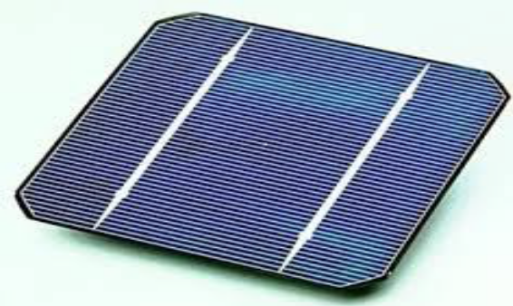
Figure 2.1: Solar Cell
St.Ann’s College of Engineering & Technology Page4
Department of CSE SOLAR TRACKING SYSTEM

2.2 Types of solar tracking technologies

There are various categories of modern solar tracking technologies;
2.2.1 Active tracker
Active trackers make use of motors and gear trains for direction of the tracker as commanded by the controller responding to the solar direction. The position of the sun is monitored throughout the day. When the tracker is subjected to darkness, it either sleeps or stops depending on the design. This is done using sensors that are sensitive to light such as LDRs. Their voltage output is put into a microcontroller that then drives actuators to adjust the position of the solar panel.
2.2.2 Passive solar tracking
Passive trackers use a low boiling point compressed gas fluid driven to one side or the other to cause the tracker to move in response to an imbalance. Because it is a non precision orientation it is not suitable for some types of concentrating photovoltaic collectors but works just fine for common PV panel types. These have viscous dampers that prevent excessive motion in response to gusts of wind.
2.2.3 Chronological solar tracking
A chronological tracker counteracts the rotation of the earth by turning at the same speed as the earth relative to the sun around an axis that is parallel to the earth’s. To achieve this, a simple rotation mechanism is devised which enables the system to rotate throughout the day in a predefined manner without considering whether the sun is there or not. The system turns at a constant speed of one revolution per day or 15 degrees per hour. Chronological trackers are very simple but potentially very accurate.
2.2.4 Single axis trackers
Single axis trackers have one degree of freedom that act as the axis of rotation. The axis of rotation of single axis trackers is aligned along the meridian of the true North. With advanced tracking algorithms, it is possible to align them in any cardinal direction. Common implementations of single axis trackers include horizontal single axis trackers (HSAT), horizontal single axis tracker with tilted modules (HTSAT), vertical single axis trackers (VSAT), tilted single axis trackers (TSAT) and polar aligned single axis trackers (PSAT)

St.Ann’s College of Engineering & Technology Page5
Department of CSE SOLAR TRACKING SYSTEM

2.2.5 Dual axis trackers
Dual axis trackers have two degrees of freedom that act as axes of rotation. These axes are typically normal to each other. The primary axis is the one that is fixed with respect to the ground. The secondary axis is the one referenced to the primary axis. There are various common implementations of dual trackers. Their classification is based on orientation of their primary axes with respect to the ground.

2.3 Advantages and Disadvantages of solar energy
There are several benefits that solar energy has and which make it favorable for many uses.
2.3.1 Advantages of Solar power
▪ Solar energy is a clean and renewable energy source.
▪ Once a solar panel is installed, the energy is produced at reduced costs.
▪ whereas the reserves of oil of the world are estimated to be depleted in future, solar energy will last forever.
▪ It is pollution free.
▪ Solar cells are free of any noise. On the other hand, various machines used for pumping oil or for power generation are noisy.
▪ Once solar cells have been installed and running, minimal maintenance is required. Some solar panels have no moving parts, making them to last even longer with no maintenance.
▪ On average, it is possible to have a high return on investment because of the free energy solar panels produce.
▪ Solar energy can be used in very remote areas where extension of the electricity power grid is costly.

St.Ann’s College of Engineering & Technology Page6
Department of CSE SOLAR TRACKING SYSTEM

2.3.2 Disadvantages of solar power
▪ Solar panels can be costly to install resulting in a time lag of many years for savings on energy bills to match initial investments.
▪ Generation of electricity from solar is dependent on the country’s exposure to sunlight. This means some countries are slightly disadvantaged.
▪ Solar power stations do not match the power output of conventional power stations of similar size. Furthermore, they may be expensive to build.
▪ Solar power is used for charging large batteries so that solar powered devices can be used in the night. The batteries used can be large and heavy, taking up plenty of space and needing frequent replacement.

Because merits are more than the demerits, the use of solar power is considered as a clean and viable source of energy. The various limitations can be reduced through various ways.

St.Ann’s College of Engineering & Technology Page7

Department of CSE SOLAR TRACKING SYSTEM

CHAPTER – 3

DESIGN AND IMPLIMENTATION

3.1 Light Sensor Theory and Circuit of Sensor Used
Light detecting sensor that maybe used to build solar tracker includes LDR . A suitable, inexpensive, simple and easy to interface photo sensor is analog LDR which is the most common in electronics. It is usually in form of a photo resistor made of cadmium sulfide (CdS) or gallium arsenide (GaAs). Next in complexity is the photodiode followed by the phototransistor
3.2 Light Dependent Resistor Theory
The simplest optical sensor is a photon resistor or photocell which is a light sensitive resistor these are made of two types, cadmium sulfide (CdS) and gallium arsenide (GaAs). The sun tracker system designed here uses two cadmium sulfide (CdS) photocells for sensing the light. The photocell is a passive component whose resistance is inversely proportional to the amount of light intensity directed towards it. It is connected in series with capacitor. The photocell to be used for the tracker is based on its dark resistance and light saturation resistance. The term light saturation means that further increasing the light intensity to the CdS cells will not decrease its resistance any further. Light intensity is measured in Lux, the illumination of sunlight is approximately 30,000 lux.
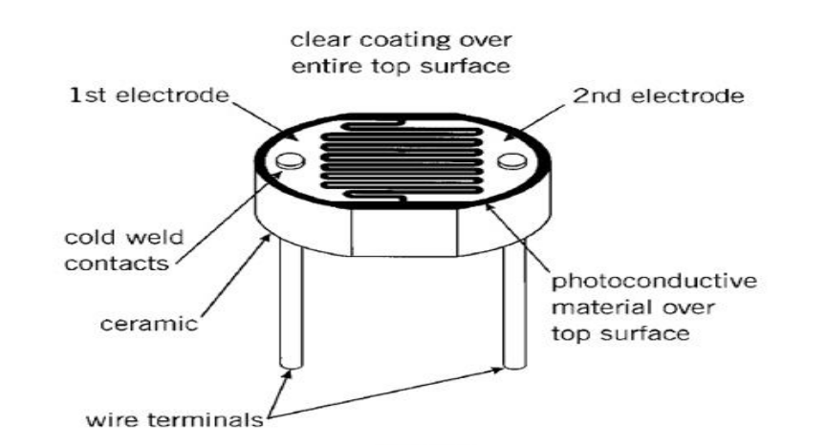

Figure 3.1: LDR construction

St.Ann’s College of Engineering & Technology Page8
Department of CSE SOLAR TRACKING SYSTEM

Normally the resistance of an LDR is very high, sometimes as high as 1000 000 ohms, but when they are illuminated with light resistance drops dramatically. When the light level is low the resistance of the LDR is high. This prevents current from flowing to the base of the transistors. Consequently the LED does not light. However, when light shines onto the LDR its resistance falls
3.2.1 The concept of using three LDRs

3.2.1 The concept of using two LDRs

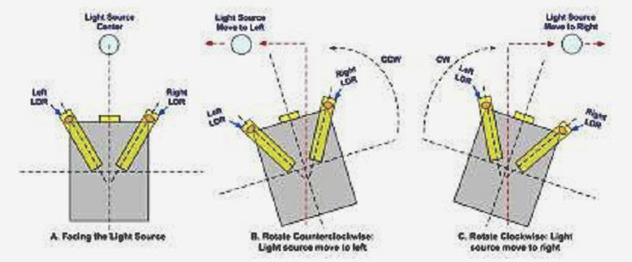

Figure 3.2: Use of three LDRs

Concept of using three LDRs for sensing is explained in the figure above. The stable position is when the three LDRs having the same light intensity. When the light source moves, i.e. the sun moves from west to east, the level of intensity falling on all the LDRs changes and this change is calibrated into voltage using voltage dividers. The changes in voltage are compared using built-in comparator of microcontroller and motor is used to rotate the solar panel in a way so as to track the light source.
3.3 Servo Motor
Servo motors are used for various applications. They are normally small in size and have good energy efficiency. The servo circuitry is built inside the motor unit and comes with a positionable shaft that is fitted with a gear. The motor is controlled with an electric signal that determines the amount of shaft movement.

St.Ann’s College of Engineering & Technology Page9
Department of CSE SOLAR TRACKING SYSTEM

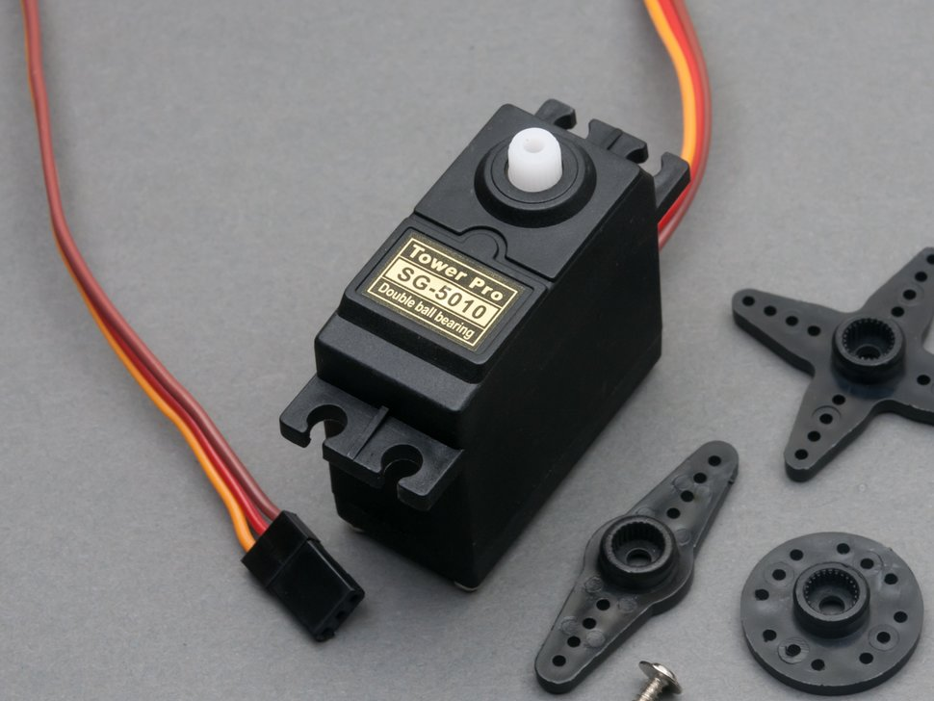

Figure 3.3: servo motor

3.3.1 Components of the servo motor
Inside the servo there are three main components; a small DC motor, a potentiometer and a control circuit. Gears are used to attach the motor to the control wheel. As the motor rotates the resistance of the potentiometer changes so the control circuit can precisely regulate the amount of movement there is and the required direction.
When the shaft of the motor is at the desired position, power supply to the motor is stopped. If the shaft is not at the right position, the motor is turned in the right direction. The desired position is sent through electrical pulses via the signal wire. The speed of the motor is proportional to the difference between the actual position and the position that is desired. Therefore, if the motor is close to the desired position, it turns slowly. Otherwise, it turns fast. This is known as proportional control.
3.3.2 How the servo is controlled
Servos are sent through sending electrical pulses of variable width, or pulse width modulation (PWM), through the control wire. There is a minimum pulse, maximum pulse and a repetition rate. Servos can usually turn only 90 degrees in either direction for a total of 180 degrees movement. The neutral position of the motor is defined as that where the servo has the same amount of potential rotation in both the clockwise and counter-clockwise direction. The PWM sent to the motor determines the position of the shaft, and based on the duration of the pulse sent through the control wire the rotor will turn to the position that is desired.

St.Ann’s College of Engineering & Technology Page10
Department of CSE SOLAR TRACKING SYSTEM

The servo motor expects to see a pulse after every 20 milliseconds and the length of the pulse will determine how far the motor will turn. For instance, a 1.5ms pulse makes the motor to turn in the 90 degrees position. If the pulse was shorter than 1.5ms, it will move to 0 degrees and a longer pulse moves it to 180 degrees. This is shown below.
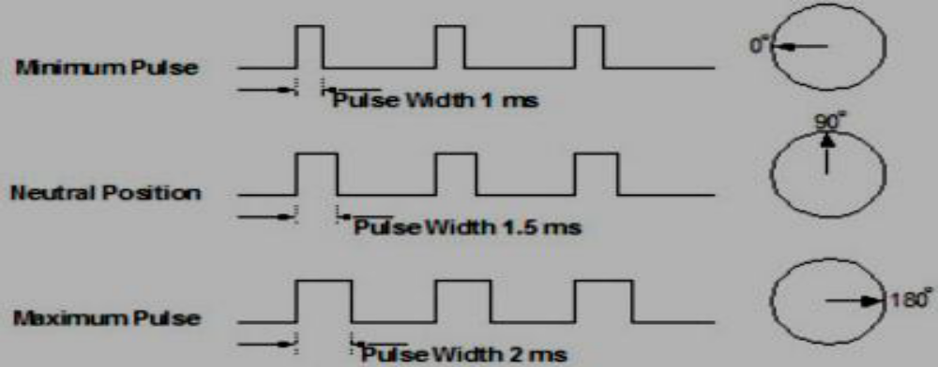
Figure 3.4: variable pulse width control servo position
For applications where there is requirement of high torque, servos are preferable. They will also maintain the torque at high speeds, up to 90% of the rated torque is available from servos at high speeds. Their efficiencies are between 80 to 90%.
A servo is able to supply approximately twice their rated torque for short periods of time, offering enough capacity to draw from when needed. In addition, they are quiet, are available in AC and DC, and do not suffer from vibrations.

3.3.3 Advantages and disadvantages of servo motors

For applications where high speed and high torque are required, servo motors are the better option. While stepper motors peak at around 2000 RPM, servos are available at much faster speeds. Servo motors also maintain torque at high speed, up to 90% of the rated torque is available from servos at high speeds. They have an efficiency of about 80-90% and supply roughly twice their rated torque for short periods. Furthermore, they do not vibrate or suffer from resonance issues.
Servo motors are more expensive than other types of motors. Servos require gear boxes, especially for lower operation speeds. The requirement for a gear box and position encoder makes the designs more mechanically complex. Maintenance requirements will also increase.

St.Ann’s College of Engineering & Technology Page11
Department of CSE SOLAR TRACKING SYSTEM

3.4 Microcontroller

Microcontroller is a single chip micro computer made through VLSI fabrication. A microcontroller also called an embedded controller because the microcontroller and its support circuits are often built into, or embedded in, the devices they control. A microcontroller is available in different word lengths like microprocessors (4bit,8bit,16bit,32bit,64bit and 128 bit microcontrollers are available today)
A microcontroller contains one or more of the following components:
• Central processing unit (CPU)
• Random Access Memory (RAM)
• Read Only Memory (ROM)
• Input/Output ports
• Timers and Counters
• Interrupt controls
• Analog to digital converters
• Digital analog converters
• Serial interfacing ports
• Oscillatory circuits
Microcontrollers need to be programmed to be capable of performing anything useful. It then executes the program loaded in its flash memory – the code comprised of a sequence of zeros and ones. It is organized in 12-, 14- or 16-bit wide words, depending on the microcontroller’s architecture. Every word is considered by the CPU as a command being executed during the operation of the microcontroller.
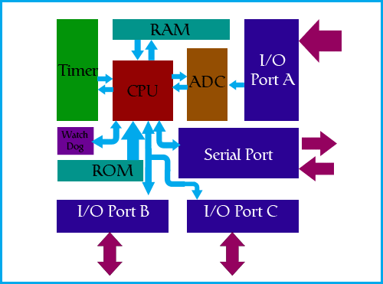
Figure 3.5: Microcontroller Architecture

St.Ann’s College of Engineering & Technology Page12
Department of CSE SOLAR TRACKING SYSTEM

3.5 Project Photo

St.Ann’s College of Engineering & Technology Page13
Department of CSE SOLAR TRACKING SYSTEM

CHAPTER – 4

CODING

#include<Servo.h>0 //Header file for Servo motor

int i=0; //Global initialization for three LDRs

#define servo_pin 5 //Declaring Servo Output pin as 5

Servo servo; //Creating object for Servo Structure

void setup()

{

pinMode(4,INPUT); //Declaring LDR-1 Input pin as 4

pinMode(7,INPUT); //Declaring LDR-1 Input pin as 7

pinMode(8,INPUT); //Declaring LDR-1 Input pin as 8

Serial.begin(9600); //Beginning Serial Communication

servo.attach(servo_pin); //Attaching Servo motor pin

servo.write(0); //Initially placing Servo Motor with 0’

Degrees

}

void loop()

{

if(digitalRead(4)==0 && digitalRead(7)==1 && digitalRead(8)==1 &&(i==0 || i==3)) //LDR-1 is open and

remaining are Closed

{

i=1;

Serial.print("LDR-1 Value :");

Serial.println(i);

servo.write(15); //rotating Servo Motor with 15’ Degrees

delay(1000);

}

else if(digitalRead(7)==0 && digitalRead(4)==1 && digitalRead(8)==1 && i==1) //LDR-2 is open and remaining

are Closed

{

i=2;

Serial.print("LDR-2 Value :");

Serial.println(i);

servo.write(60); //rotating Servo Motor with 60’

Degrees

delay(1000);
}

St.Ann’s College of Engineering & Technology Page14

Department of CSE SOLAR TRACKING SYSTEM

else if(digitalRead(8)==0 && digitalRead(4)==1 && digitalRead(7)==1 && i==2) //LDR-2 is open and remaining are Closed

{

i=3;

Serial.print("LDR-3 Value :");

Serial.println(i);

servo.write(110); //rotating Servo Motor with 110’ Degrees

delay(1000);

}

else if(digitalRead(8)==1 && digitalRead(4)==1 && digitalRead(7)==1 && i==3) //All the LDRs are Closed

{

i=0;

Serial.print("LDR-1 Value :");

Serial.println(i);

servo.write(0); //Place the Solar Panel to its Initial Position

(0’Degrees)

delay(1000);

}

else

{

delay(5);

}

}

St.Ann’s College of Engineering & Technology Page15

Department of CSE SOLAR TRACKING SYSTEM

Output:
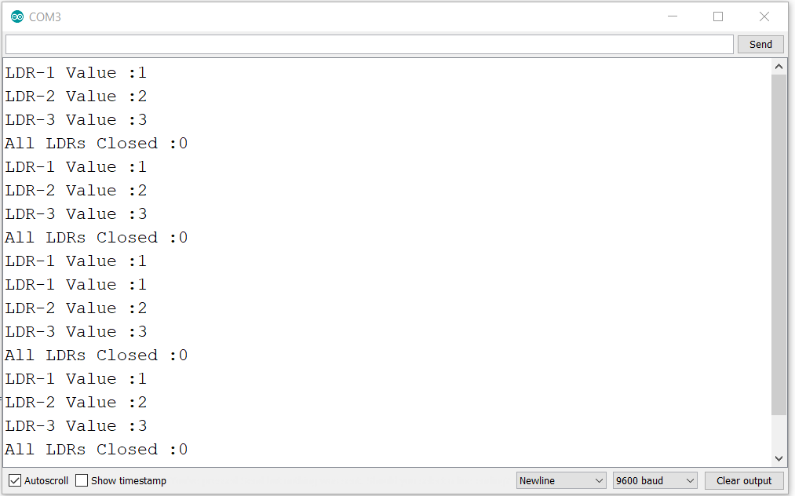
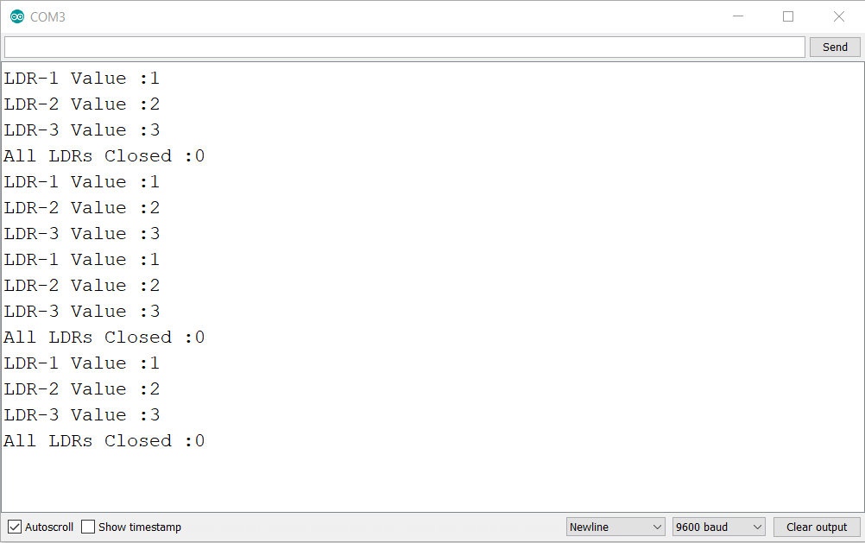

St.Ann’s College of Engineering & Technology Page16

Department of CSE SOLAR TRACKING SYSTEM

CHAPTER – 5

DISCUSSION

5.1 Discussion
The objective of the project was to design a system that tracks the sun for a solar panel. This was achieved through using light sensors that are able to detect the amount of sunlight that reaches the solar panel. The values obtained by the LDRs are compared and if there is a significant difference, there is actuation of the panel using a servo motor to the point where it is almost perpendicular to the rays of the sun.
This was achieved using a system with three stages or subsystems. Each stage has its own role.
The stages were;
➢ An input stage that was responsible for converting sunlight to a voltage.
➢ A control stage that was responsible for controlling actuation and decision making.
➢ A driver stage with the servo motor. It was responsible for actual movement of the panel.
The input stage is designed with a voltage divider circuit so that it gives desired range of illumination for bright illumination conditions or when there is dim lighting. This made it possible to get readings when there was cloudy weather. The potentiometer was adjusted to cater for such changes. The LDRs were found to be most suitable for this project because their resistance varies with light. They are readily available and are cost effective. Temperature sensors for instance would be costly.

The control stage has a microcontroller that receives voltages from the LDRs and determines the action to be performed. The microcontroller is programmed to ensure it sends a signal to the servo motor that moves in accordance with the generated error.

The final stage was the driving circuitry that consisted mainly of the servo motor. The servo motor had enough torque to drive the panel. Servo motors are noise free and are affordable, making them the best choice for the project.

St.Ann’s College of Engineering & Technology Page17
Department of CSE SOLAR TRACKING SYSTEM

CHAPTER – 6

CONCLUSION
AND
FUTURE EXTENSIONS

6.1 Conclusion

A solar panel that tracks the sun was designed and implemented. The required program was written that specified the various actions required for the project to work. As a result, tracking was achieved. The system designed was a single axis tracker. While dual axis trackers are more efficient in tracking the sun, the additional circuitry and complexity was not required in this case.
This is because Kenya lies along the equator and therefore there are no significant changes in the apparent position of the sun during the various seasons. Dual trackers are most suitable in regions where there is a change in the position of the sun.
This project was implemented with minimum resources. The circuitry was kept simple, while ensuring efficiency is not affected.

6.2 Future Extensions

With the available time and resources, the objective of the project was met. The project is able to be implemented on a much larger scale. For future projects, one may consider the use of more efficient sensors, but which are cost effective and consume little power. This would further enhance efficiency while reducing costs. If there is the possibility of further reducing the cost of this project, it would help a great deal. This is because whether or not such projects are embraced is dependent on how cheap they can be.
Shading has adverse effects on the operation of solar panels. Shading of a single cell will have an effect on the entire panel because the cells are usually connected in series. With shading therefore, the tracking system will not be able to improve efficiency as is required.

St.Ann’s College of Engineering & Technology Page18
Department of CSE SOLAR TRACKING SYSTEM

CHAPTER – 7

REFERENCES

[1] Arduino Project Hub: https://create.arduino.cc/projecthub/FIELDING/solar-panel-sun-tracker-phone-charger-f669ce?ref=search&ref_id=solar%20tracking%20syste,m&offset=1.

[2] Wikipedia: https://en.wikipedia.org/wiki/Solar_tracker

[3] Electronicsforu: https://electronicsforu.com/electronics-projects/solar-tracking-system

St.Ann’s College of Engineering & Technology Page19

